**SEND KAS MOBILE KEYS VIA TCP**

**1. Find the PMS Server Address to send TCP Commands:**

PMS Server address:

External ip: 27.113.241.146. Port:10003. for testing PMS on White laptop remotely.  
The white laptop is setup and running at all times so developers can test against it. Please let us know if machine is not up.

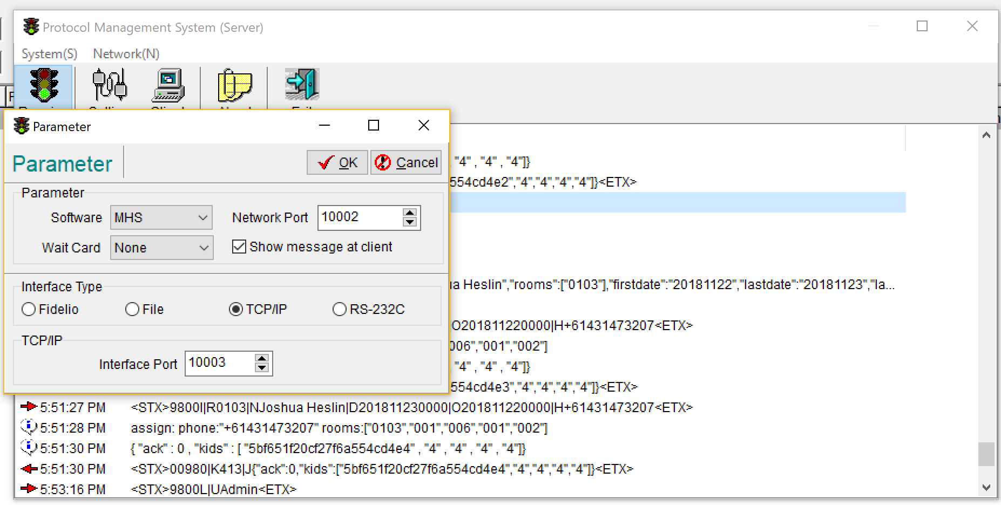

* Note: client needs to ensure their public IP address has port forward settings to the location of the PMS Server.

**1. Send Mobile Key:**

Example:

<STX>9800I|R<roomnumber>|N<name>|D<starttime>|O<endtime>|H<mobilenumber><ETX>

* 1 room per command, for more than 1 mobile key, send multiple commands

Response:

<STX>00980|K<cardNumber>|J<jsonPacket><ETX>

* Test for successs, <jsonPacket> string contains “ack:0”

PMS Server Log:

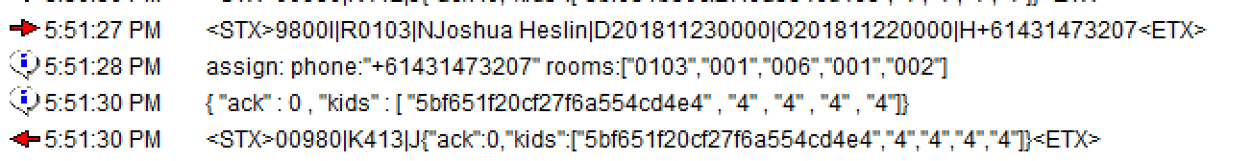

**2. Check out Mobile Key:**

Example:

<STX>9800B|H<mobilenumber><ETX>

Response:

<STX>00980|J<jsonPacket><ETX>

* Test for successs, <jsonPacket> string contains “ack:0”

PMS Server Log:

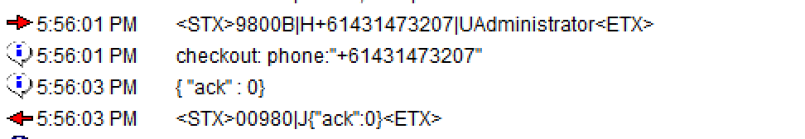

**3. Send Booking Info To Software (RFID card issue on guest arrival manually):**

